28.24: There is no magnetic field at the center of the loop from the straight sections.
The magnetic field from the semicircle is just half that of a complete loop:
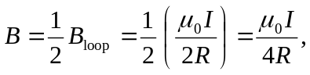
into the page.

